Moment of Truth Mapping Worksheet

In order to exceed your guests’ expectations, you must pay attention to detail and be guest-centered. Consider the touch points for your area when writing out your service standards.
- Use the service map below by choosing a moment of truth interaction and writing the steps it takes to complete the interaction. There may be more or less steps for the interaction you choose.
- With each step, consider what makes this good, bad or indifferent service.
- From there write out your service standards for good service for that moment of truth interaction.

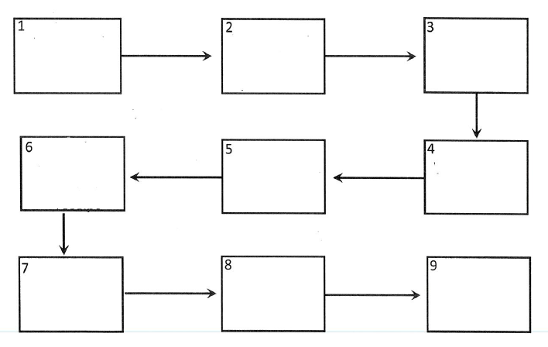
Service Map:
Steps: Write out each service standard.

1.
_________________________________________________________________________

_________________________________________________________________________

Good: _______________________________________________________________

Indifferent: ___________________________________________________________

Bad: ________________________________________________________________

2. ._________________________________________________________________________

_________________________________________________________________________

Good: _______________________________________________________________

Indifferent: ___________________________________________________________

Bad: ________________________________________________________________

3. ._________________________________________________________________________

_________________________________________________________________________

Good: _______________________________________________________________

Indifferent: ___________________________________________________________

Bad: ________________________________________________________________

4. .________________________________________________________________________

_________________________________________________________________________

Good: _______________________________________________________________

Indifferent: ___________________________________________________________

Bad: ________________________________________________________________

5. ._________________________________________________________________________

_________________________________________________________________________

Good: _______________________________________________________________

Indifferent: ___________________________________________________________

Bad: ________________________________________________________________

