OKLAHOMA STATE UNIVERSITY
NEW EMPLOYEE INFORMATION

WELCOME TO OSU!

BENEFITS/NEW EMPLOYEE ORIENTATION (NEO)
You will receive an email prior to NEO with the room/building location.

BENEFITS EFFECTIVE: BANNER ID: HR CONSULTANT: PHONE NUMBER: HR CONSULTANT EMAIL: FIRST PAYCHECK: PAY PERIOD :

Within this packet are two forms for you to sign and return to your HR Consultant on your first day:

- Confidentiality Agreement
- Policies and Procedures Attestation

OSU Human Resources is located on the OSU Center for Health Sciences campus
1111 W. 17th St North Hall Suite 428 | Phone: 918.561.1200 | Fax: 918.561.1208 | Email: tulsa.hr@okstate.edu

MY.OKSTATE.EDU
Many of the tools you will need can be found in the Employee Self Service within the Banner system. Simply login to your account at my.okstate.edu using your OSU username, which is either your OSU email address or short name provided by OSU, and password you created when setting up your OKEY account (instructions below under email).
Once logged in:
- select “OSU Stillwater/Tulsa”
- click on “Employee” at the top of the page

Time Sheet:
Select “Employee Dashboard” and “enter time”
Select “Start Timesheet” and select the clock in button

Leave Report:
Select “Employee Dashboard” and “enter leave”
Select “Start Leave Report” and enter leave hours

Also under “Employee Dashboard”
Pay Information: Direct deposit enrollment, Paystub
Tax Forms: W-4 information, W-2 form, 1095-C form
Leave Balances: Totals of leaves earned, taken and available

Benefits: Enroll, Verify, Qualifying Event – Enroll, change and view current benefits

EMAIL
To set up your OSU email (OKEY account) you must have your PIN. Your PIN will be sent to the email account you provided on your Personal Information Form (in HR) 4–7 days after your payroll paperwork is complete. The subject of the email will be “Your OSU Orange Key Account is Ready to Activate.” Be sure to check your spam folder as well.
You may activate your OKEY account from the following website: okey.okstate.edu. For help activating your email account contact the Tulsa Helpdesk at 405.744.4357. If you do not receive an email with your pin, go to okey.okstate.edu and select the option “activate account.”

DIRECT DEPOSIT
After your OKEY is set up per the above instructions you will need to set up your Direct Deposit information for your payroll. This should be completed on or before your first day of work. For instructions on Direct Deposit set up go to: https://adminfinance.okstate.edu/payroll/files/guides-forms/direct-deposit-on-self-service.pdf

TIMEKEEPING AND LEAVE REPORTS
For information regarding biweekly paid employee timekeeping and how to clock in and out, go to:
https://hr.okstate.edu/hrim/banner-resources.html.
For information regarding monthly paid employee leave reports, go to: https://hr.okstate.edu/hrim/banner-resources.html.

OSU POLICIES AND PROCEDURES
OSU Policies & Procedures can be found at: tulsa.okstate.edu. Click on “faculty/staff” at the top and then “Human Resources.” Scroll down, on the right side, click on “OSU Tulsa Policies and Procedures.”

ID BADGES
OSU-Tulsa: Bring a photo ID and your Banner ID number to North Hall, Room 357.

YOUR PAYROLL ADVICE

OSU processes more than 180,000 paychecks to approximately 17,000 individuals each year. Each paycheck requires numerous transactions and calculations which involve earnings, taxes, deductions, and benefits.
Although the system provides many checks and balances, errors can occur. Thus, OSU provides Payroll Advices to employees several days ahead of pay dates so employees may review and verify their pay. If a discrepancy is discovered, an employee should notify his or her supervisor immediately to avoid further delays in pay.

TRANSITION TO A PAPERLESS PAYROLL ADVICE
As of July 1, 2005, OSU began processing the Payroll Advice electronically. The paperless form of the Payroll Advice can be found on Banner Self Service. Banner Self Service is a feature of the Human Resource System that allows employees of OSU to view payroll information, leave balances, and other employee information. Enhancements to Banner Self Service are continually being made; therefore, the example on the back of this handout may look somewhat different than the Banner Self Service Pay Stub.

EMAIL NOTIFICATIONS
An email notification will be sent to all employees processed in a payroll calculation. The email will inform the employee that he/she has been included in a particular payroll calculation with a specified issue date. It will also include the net pay along with the check distribution/bank name. A link to Banner Self Service will be provided in the email or employees can access the Banner Self Service Employee Pay Stub directly by logging in at my.okstate.edu.
The email will also contain a section of Notifications and Announcements. This will contain important information about pay and benefits.

ACCESSING BANNER SELF SERVICE
Banner Self Service can be accessed by using an employee’s OKEY UserID or email address and password at the OKEY Sign in Service Page.
To access pay information for a particular payroll, double click on the Employee tab, then click on Pay Stub. Select the Pay Stub Year and click on the Display button, then click on the Pay Stub Date.
To view leave information, double click on the Employee tab, then click on Leave Balances. This will provide the employee with a table of annual leave, comp time, sick leave, and extended sick leave balances.

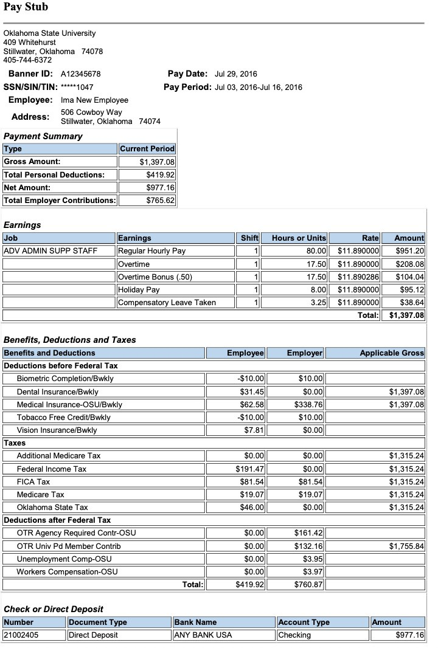

WORKERS’ COMPENSATION, UNEMPLOYMENT COMPENSATION AND SOCIAL SECURITY/MEDICARE
Federal and state laws determine the eligibility requirements and the type of coverage for these benefits. Students may be exempt from some benefits.

WORKERS’ COMPENSATION
OSU provides Workers’ Compensation (WC) coverage for all employees for work-related injuries or illnesses. The coverage provides reasonable and necessary medical treatment and some income replacement. In addition, an injured employee may be entitled to prosthetic devices, physical rehabilitation, vocational rehabilitation, or permanent disability compensation. If the work-related injury or illness causes death, the employee’s dependents may be entitled to additional benefits.
Employees shall notify supervisors immediately when a work-related injury or illness occurs so that medical attention may be provided, if needed. Medical treatment will be provided at designated health care providers, when available. University Health Services will provide non-emergency care within the Stillwater area during normal business hours. Supervisors report work-related injuries and illnesses through the OSU WC process as described at hr.okstate.edu/benefits/workcomp. For further information, please contact OSU Human Resources at 405-744-7420.
Employees may use accrued leave for the official waiting period as defined by Oklahoma statute. For injuries or illnesses occurring on or before January 31, 2014, the official waiting period is seven full days of absence, following the date of injury or illness, as required by the treating physician. For injuries or illnesses occurring on or after February 1, 2014, the official waiting period is three full days of absence, following the date of injury or illness, as required by the treating physician. After the waiting period lapses, Broadspire, OSU’s third-party administrator, will pay for qualified absences as required by Oklahoma statute. For more information, please refer to the publication Benefits During Absences Due to Workplace Injuries/Illnesses as found at hr.okstate.edu/benefits/workcomp. If the employee does not wish to use his/her leave for the official waiting period (either seven days or three days) or to supplement payment from Broadspire after the waiting period, the employee must provide a written request to his/her supervisor.
Employees on an extended WC leave (full month or longer without pay) should contact Employee Services, 405-744-5449, about benefits. You may qualify for family/medical leave, and those benefits would run concurrently with your WC leave. OSU-paid health coverage will continue during WC leave. Life coverage will continue for no longer than one year unless an ING life waiver is approved due to disability. Employee-paid benefits will be billed through the Bursar’s office if there is insufficient pay to take the deductions.
The Oklahoma Workers’ Compensation Counselor Program, at 800-522-8210, offers employees free, private counseling concerning work-related injuries or illnesses. This service is offered to provide clear, unbiased answers to sometimes complex WC questions. You may also visit their website at owcc.state.ok.us.

UNEMPLOYMENT COMPENSATION INSURANCE
The provisions of the Oklahoma Employment Security Act apply to most OSU employees. OSU pays the full cost of these benefits. The Oklahoma Employment Security Commission determines eligibility of a terminated employee for unemployment benefits based upon the circumstances of the termination. For more information review their website at oesc.state.ok.us.

SOCIAL SECURITY/MEDICARE
Both you and OSU contribute to Social Security and Medicare. Benefits provided by Social Security include old age, survivors, and disability insurance and are explained in detail at www.ssa.gov. Medicare benefits include Part A (hospitalization), Part B (medical insurance), and Part D (prescription coverage).

OSU Human Resources developed this information for the convenience of OSU employees. It is a brief interpretation of more detailed and complex materials. If further clarification is needed, the actual law, policy, and contract should be consulted as the authoritative source. OSU continually monitors benefits, policy, and procedures and reserves the right to change, modify, amend, or terminate benefit programs at any time

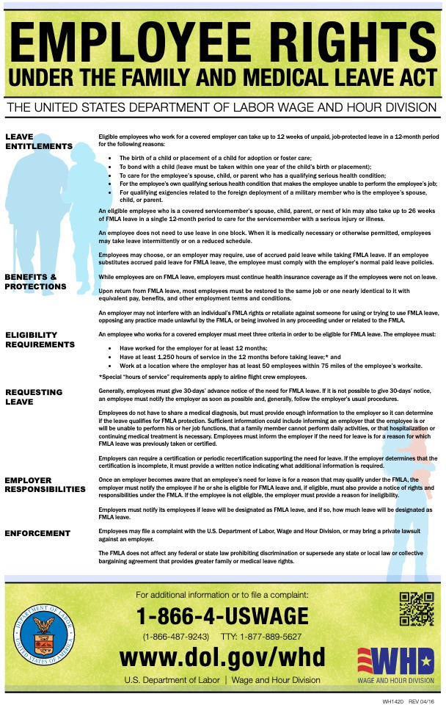

DRUG-FREE WORKPLACE STATEMENT

TO ALL EMPLOYEES

In accordance with the Drug-Free Workplace Act of 1988, Oklahoma State University hereby notifies all employees that the unlawful manufacture, distribution, dispensation, possession or use of a controlled substance is prohibited in the workplace. Any employee found to have violated this prohibition may be subject to disciplinary action up to and including dismissal or be required to satisfactorily participate in a drug abuse assistance or rehabilitation program as a condition of continued employment. The drug abuse assistance/rehabilitation program shall be one that has been previously approved for such purposes by federal, state, or local health, law enforcement or other appropriate agency. The imposition of such disciplinary action or requirement to satisfactorily participate in a drug abuse assistance/rehabilitation program is premised solely upon a violation of this prohibition and does not require a criminal conviction.
As a condition of employment at Oklahoma State University, all employees will:
- Comply with the terms of this statement; and
- Notify the University (through either their immediate supervisor, other supervisory administrator or project director) of any criminal drug statute conviction for a violation occurring in the workplace in writing no later than five days after such conviction.
Such conviction may, of course, result in the employee being disciplined or required to satisfactorily participate in a drug abuse assistance/rehabilitation program as specified above. Failure of an employee to report his/her conviction, as required herein, constitutes grounds for dismissal.
As a further requirement of the Drug-Free Workplace Act, the University has established a drug-free awareness program for the purpose of informing employees about the dangers of drug abuse in the workplace, the University’s prohibition of controlled substances in and on OSU property, any available drug counseling, rehabilitation and employee assistance programs, and the penalties that may be imposed for drug abuse violations. An Employee Assistance Program has been
created in furtherance of the drug-free awareness program. Information about the drug-free awareness program and the Employee Assistance Program may be obtained from University Counseling Services.
Reference is made to Policy and Procedures Letter 1-1205 and the Drug-Free Workplace Act of 1988 as sources of information and clarification.

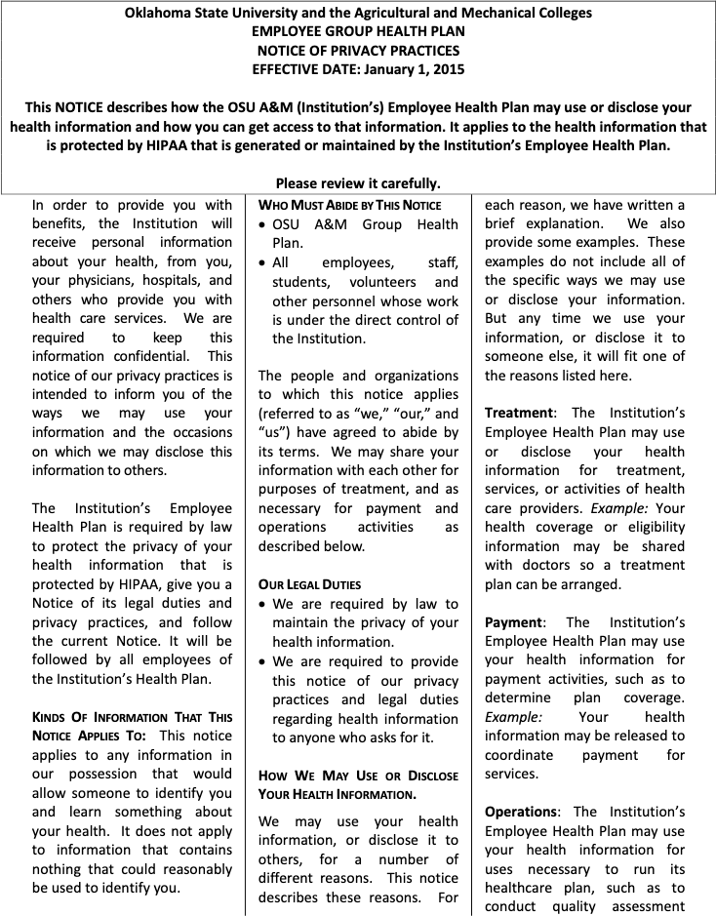

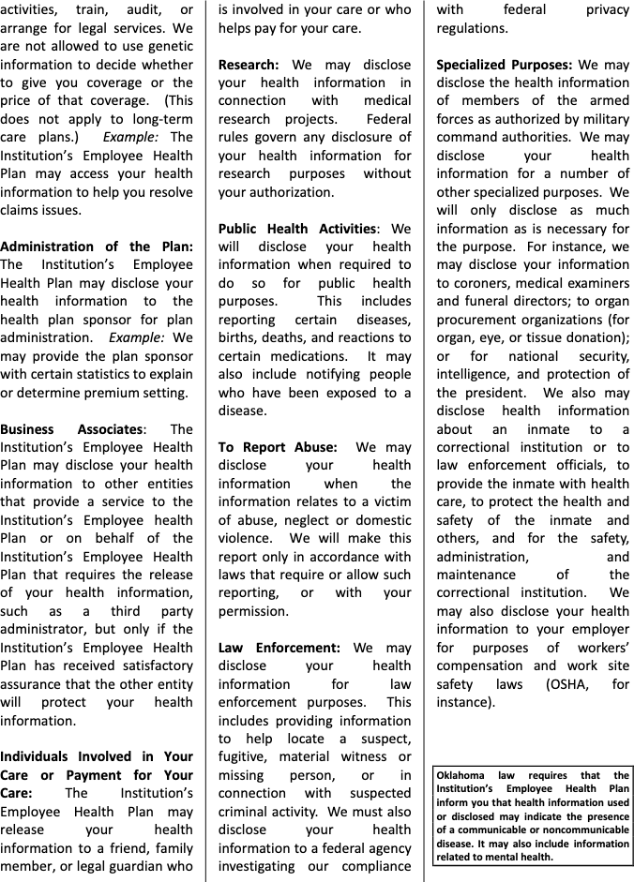

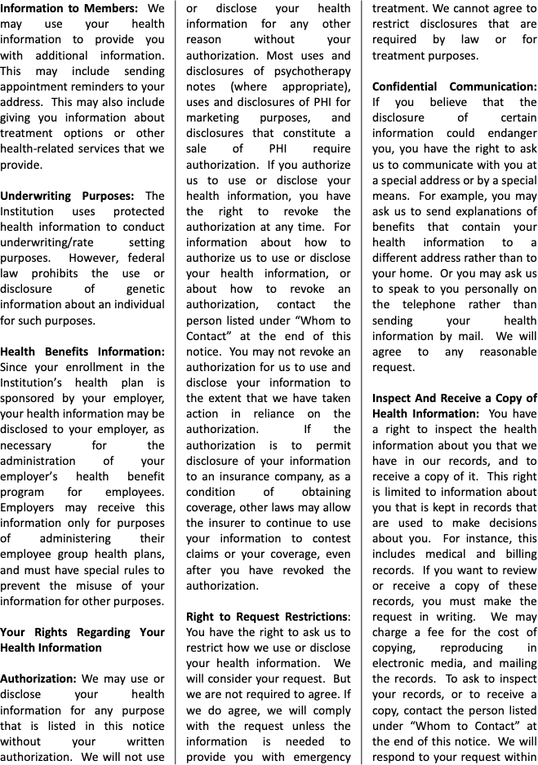

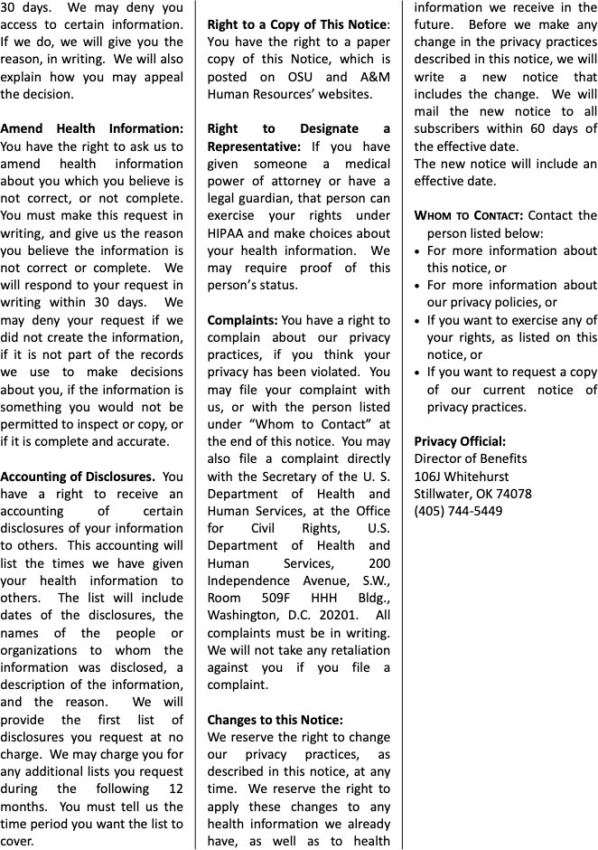

CONFIDENTIALITY AGREEMENT
I understand during the course of assignment at OSU-Tulsa I may see or hear confidential information such as financial data, social security numbers, student records and operational information pertaining to the business that OSU-Tulsa is obligated to maintain as confidential.
By signing this document I understand and agree that:
I will not access or view any information other than what is required to do my job. If I have any questions about whether access to certain information is required for me to do my job, I will immediately ask my supervisor for clarification.
I will not make any unauthorized transmissions, copies, disclosures, inquiries, modifications, or purging of confidential information.

SIGNATURE: DATE:

PRINT NAME:

POLICY AND PROCEDURES
I have been advised of the OSU Policies and Procedures and agree to review these policies and procedures found on the OSU web page:

tulsa.okstate.edu
Hover over “Faculty/Staff” at the top of the page and click on Human Resources in the left column. There is a Quick Link for “OSU-Tulsa Policies and Procedures” towards the bottom of the page.

SIGNATURE: DATE:

